**EMAIL FROM HR TO EMPLOYEES**

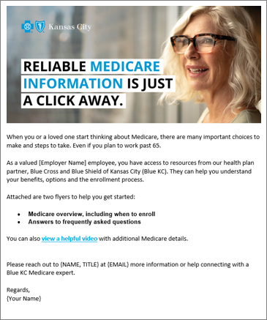 ***Instructions for HR***

* There are two email header images on the following page that you can use at the top of your email. Simply drag and drop the image into your email.
* You will find our suggested subject line and copy for the email on the following page.
* Simply copy and paste both the image and the copy into MS Outlook. If you’re using another email distribution method, some reformatting may be required.
* For further information on how to send a bulk email to multiple contacts through Outlook please reference this easy how-to guide: <https://bit.ly/38AkcQJ>
* When copying and pasting the content, we recommend you keep the source formatting. For tips on formatting, please refer to this handy link: [view here](https://www.microsoft.com/en-us/microsoft-365/blog/2012/02/10/tip-how-to-cut-and-paste-without-messing-up-formatting/)

***Visual example for Copy Layout***

We recommend formatting the email text body copy to the following styles:

Arial, Regular 12pt | Black Text Color: # 000000

**If you have any additional questions about the content, please contact your broker or Blue KC representative.**

*Email Header Image Option 1:*



*Email Header Image Option 2:*



***Email Subject Line***

**Helpful Medicare resources are available for you and your loved ones**

***Attachments***

*Add the Overview flyer and QA flyer from under One-Pagers*

*Body Copy:*

When you or a loved one start thinking about Medicare, there are many important choices to make and steps to take. Even if you plan to work past 65.

As a valued [Employer Name] employee, you have access to resources from our health plan partner, Blue Cross and Blue Shield of Kansas City (Blue KC). They can help you understand your benefits, options and the enrollment process.

Attached are two flyers to help you get started:

* **Medicare overview, including when to enroll**
* **Answers to frequently asked questions**

You can also view a [**helpful video**](https://youtu.be/pxD3Kb36hVY) and visit [**MedicareBlueKC.com/learn**](MedicareBlueKC.com/learn) for additional Medicare details.

Please reach out to {NAME, TITLE} at {EMAIL} for more information or help connecting with a Blue KC Medicare Advisor.

Regards,

{Your Name}