**EMAIL FROM HR TO MANAGERS & SUPERVISORS**

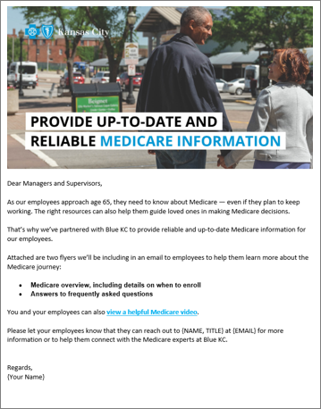 ***Instructions for HR***

* There are two email header images on the following page that you can use at the top of your email. Simply drag and drop the image into your email.
* You will find our suggested copy for the email on the following page.
* Simply copy and paste both the image and the copy into MS Outlook. If you’re using another email distribution method, some reformatting may be required.
* For further information on how to send a bulk email to multiple contacts through Outlook please reference this easy how-to guide: <https://bit.ly/38AkcQJ>
* When copying and pasting the content, we recommend you keep the source formatting. For tips on formatting, please refer to this handy link: [view here](https://www.microsoft.com/en-us/microsoft-365/blog/2012/02/10/tip-how-to-cut-and-paste-without-messing-up-formatting/)

***Visual Example for Copy Layout***

We recommend formatting the email text body copy to the following styles:

Arial, Regular 12pt | Black Text Color: # 000000

**If you have any additional questions about the content, please contact your broker or Blue KC representative.**

*Email Header Image Option 1:*



*Email Header Image Option 2:*

**

***Email Subject Line***

**NEW Medicare resources to support our employees**

***Attachments***

*Add the Overview flyer and QA flyer from under One-Pagers*

***Body Copy***

Dear Managers and Supervisors,

As our employees approach age 65, they need to know about Medicare — even if they plan to keep working. The right resources can also help them make informed Medicare decisions for themselves or help guide loved ones who are evaluating Medicare options.

That’s why we’ve partnered with Blue Cross and Blue Shield of Kansas City (Blue KC) to provide reliable and up-to-date Medicare information.

Attached are two flyers we’ll be including in an upcoming email to employees to help them learn more about the Medicare journey:

* **Medicare overview, including details on when to enroll**
* **Answers to frequently asked questions**

You can also view a [**helpful video**](https://youtu.be/pxD3Kb36hVY) and visit **MedicareBlueKC.com/learn** for additional Medicare details.

Please let your employees know that they can reach out to their Blue KC Medicare Advisor {NAME, TITLE} at {EMAIL} for more information.

Regards,

{Your Name}